LAB ASSIGNMENT – 12.4
S.ROHITH
2303A52262
BATCH.NO - 43

TASK-1: Bubble Sort for Ranking Exam Scores

Explanation
Bubble Sort repeatedly compares adjacent elements and swaps them if they are in the wrong order.
After each pass, the largest unsorted element moves to its correct position.
If no swaps occur in a pass, the algorithm stops early (early termination condition). Bubble Sort Code
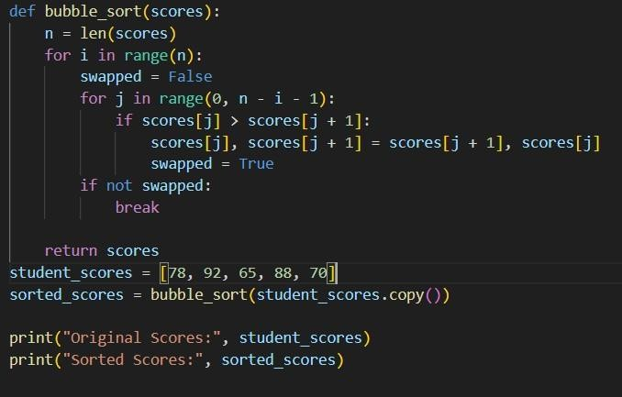

Output
Original Scores: [78, 92, 65, 88, 70] Sorted
Scores: [65, 70, 78, 88, 92]
Task 2: Improving Sorting for Nearly Sorted Attendance Records

Explanation
Bubble Sort checks all adjacent pairs even if the list is almost sorted.
Insertion Sort is more efficient for nearly sorted data because it only shifts misplaced elements.
For partially sorted attendance records, Insertion Sort performs fewer operations. Bubble Sort Code
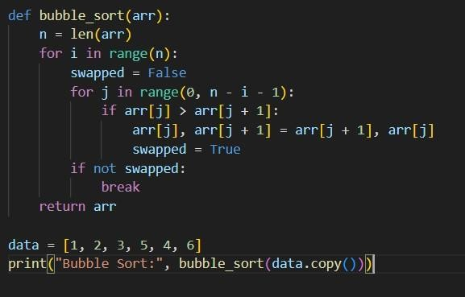
Insertion Sort Code
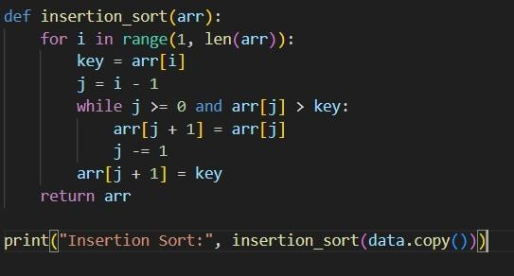
Output
Bubble Sort: [1, 2, 3, 4, 5, 6]
Insertion Sort: [1, 2, 3, 4, 5, 6]

Task 3: Searching Student Records
Explanation
Linear Search works for unsorted data by checking each element one by one.
Binary Search works only on sorted data and reduces search space by half each step.
Binary Search is faster for large sorted datasets.
Time Complexity:
Linear Search → O(n)
Binary Search → O(log n)
Linear Search Code
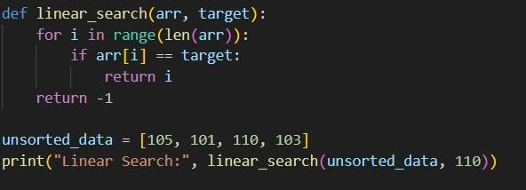
Binary Search Code
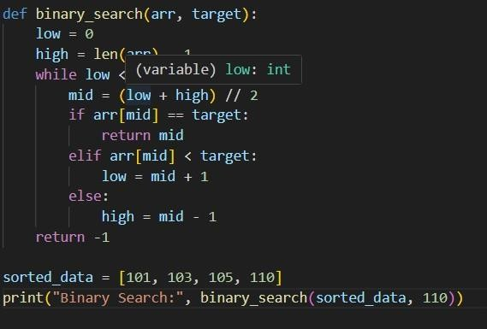
Output
Linear Search: 2
Binary Search: 3
Task 4: Choosing Between Quick Sort and Merge Sort
Explanation
Quick Sort selects a pivot and partitions elements around it recursively.
Merge Sort divides the list into halves and merges them after sorting.
Merge Sort guarantees O(n log n) performance, while Quick Sort may degrade to O(n²).
Best/Average/Worst Complexity:
Quick Sort → O(n log n) / O(n log n) / O(n²) Merge
Sort → O(n log n) in all cases
Quick Sort Code
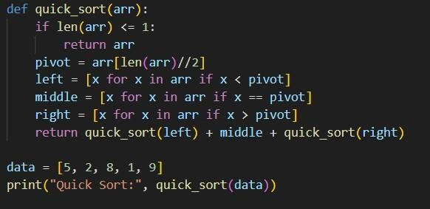

Merge Sort Code
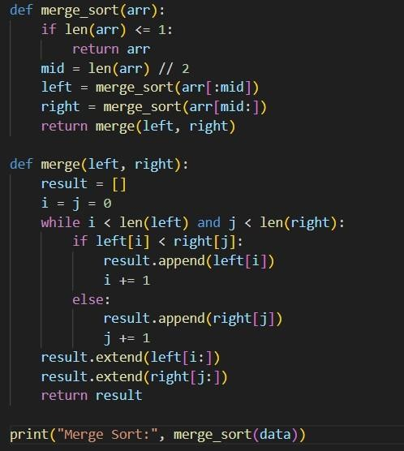
Output
Quick Sort: [1, 2, 5, 8, 9]
Merge Sort: [1, 2, 5, 8, 9]
Task 5: Optimizing a Duplicate Detection Algorithm
Explanation
The naive approach compares every pair of elements using nested loops, resulting in O(n²) time complexity.
Using a set allows constant-time lookups, reducing the complexity to O(n).
For large datasets, the optimized method significantly improves performance.
Time Complexity:
Brute-force → O(n²)
Optimized → O(n)
For large input sizes, O(n²) grows very quickly, while O(n) increases linearly and scales efficiently.
Brute-Force Code (O(n²))
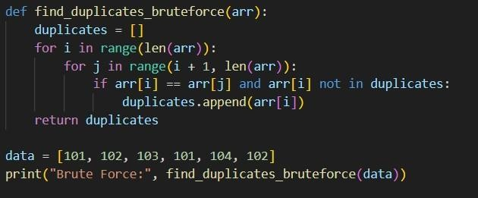
Optimized Code (O(n))
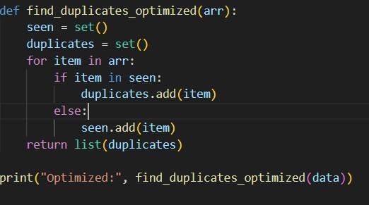
Output
Brute Force: [101, 102] Optimized: [101, 102]

